**Addition of two numbers :**

DISPLAY MACRO MSG

LEA DX, MSG

MOV AH, 09H

INT 21H

ENDM

DATA SEGMENT

N1 DB 10, 13, 'ENTER 1ST NO. : $'

N2 DB 10, 13, 'ENTER 2ND NO. : $'

N3 DB 10, 13, 'RESULT IS : $'

DATA ENDS

CODE SEGMENT

ASSUME CS : CODE, DS : DATA

START :

MOV AX, DATA

MOV DS, AX

DISPLAY N1

MOV AH, 01H

INT 21H

MOV BL, AL

DISPLAY N2

MOV AH, 01H

INT 21H

DISPLAY N3

ADD BL, AL

SUB BL, 48D

MOV DL, BL

MOV AH, 02H

INT 21h

MOV AH, 4CH

INT 21H

CODE ENDS

END START

**Addition of two numbers (With using Procedure) :**

DISPLAY MACRO MSG

LEA DX,MSG

MOV AH,09H

INT 21H

ENDM

DATA SEGMENT

N1 DB 10,13,'ENTER 1ST NO. : $'

N2 DB 10,13,'ENTER 2ND NO. : $'

N3 DB 10,13,'RESULT IS : $’

DATA ENDS

CODE SEGMENT

ASSUME CS:CODE , DS:DATA

START :

MOV AX,DATA

MOV DS,AX

DISPLAY N1

CALL INPUT

MOV BL,AL

DISPLAY N2

CALL INPUT

DISPLAY N3

ADD BL,AL

SUB BL,48D

MOV DL,BL

MOV AH,02H

INT 21h

MOV AH,4CH

INT 21H

INPUT PROC

MOV AH, 01H

INT 21H

RET

INPUT ENDP

CODE ENDS

END START

**OUTPUT :**

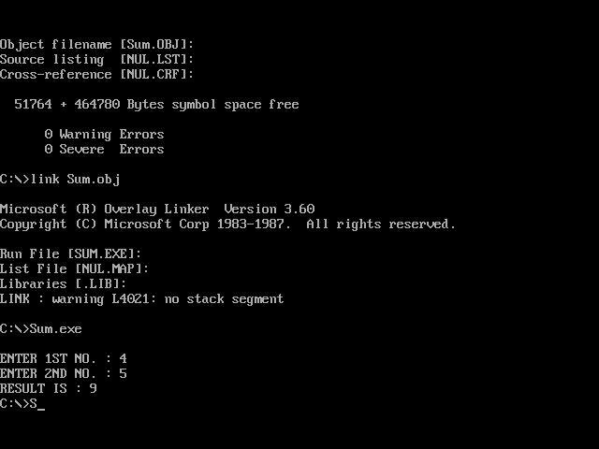

**Q.** **Program for NEAR procedure.**